CONCEPT 1
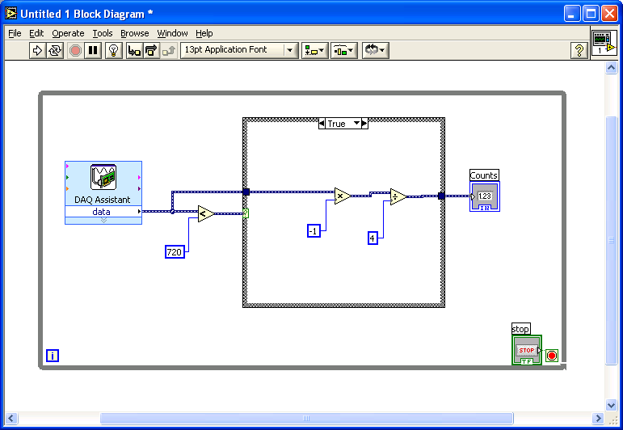
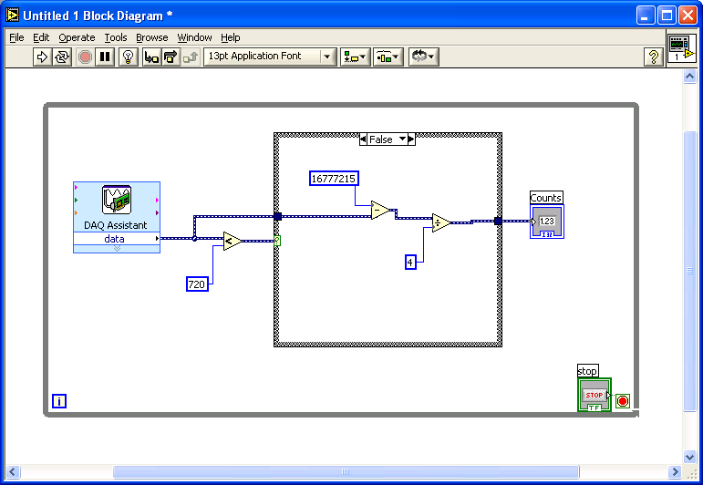
Circuit Board | Screw Terminal
U/D | 30
SRC | 47
INP | NOT CONNECTED
5V | 34
DGND | 33

CONCEPT 2
