**Homework – Op-Amps**

Email PDF version no later than beginning of next class.

1. What are the two rules for op-amps? What are the 5 properties of op-amps? (*10 points*)
2. Derive the input-output relationship and describe its physical functional *(20 points)*

nonInvertingOpAmp

A.

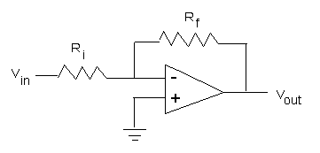

B.

diffOpAmp

C.

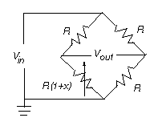

D.

1. In lab, you demonstrated aliasing. Include your commented source code (alias1_0.nxc) and 4 XLS plots of captured data: (1) fast sampling; (2) ok sampling; (3) marginal sampling; and (4) poor (aliased) sampling. Label your XLS files according. Point deductions for missing axes labels, units, and vague titling. Briefly describe why the 4 plots make sense given the source signal that was captured? *(10 points)*
2. Write a program called celsius2_0.nxc. Prepare your LM35 sensor to measure and write temperature (in Celsius and Fahrenheit) into a file called lm35.csv. Set the sampling time (say 1.5 seconds) for a total time of 5-min (300 seconds). Prepare a thermal source (e.g. hot pot or ice bath and attached your LM35 (NB: the LM35 and circuitry are not waterproof so don’t submerge in liquid!). Execute celsius2_0.nxc. Remove the LM35 after a few seconds so that the sensor returns to room temperature. Include screen shots of Brick’s display as it runs program. Plot XLS data (may have to stitch multiple files lm35-1, lm35-2, etc in one before plotting). Be sure label axes with titles and units. Include code for celsius2_0.nxc and any associated header files *(60 points)*