**Hands-on Lab**

### Motorized Damped Compound Pendulum – PID Control

# **Preamble:**

Recall that system identification was performed on a damped compound pendulum (DCP) and revealed second order dynamics; the pendulum oscillates and eventual comes to a stop due to damping. Below is a motorized version of the DCP. Commanding the motor to spin, the propeller will generate lift. The lift force acts on along the length of the pendulum, resulting in a torque around the pivot point. Again, due to the pendulum’s second order dynamics, the pendulum’s angle will oscillate over time – eventually reaching a steady-state value. This steady-state angle balances the torques due to lift and gravity.



**Concept 1 System Response**

**1-1: Capture input-output response**

**Step 1:** Clamp the motorized DCP with **Port 1** connected to the Mindsensor MTRMX-Nx motor driver and **Port 2** connected to the HiTechnic angle sensor.

**Step 2:** Download, compile and execute **pendulumOlsr1_1.nxc**. Observe NXT screen.

This code is an open-loop step response. The motor command is set to 128 (halfway between 0 and 255). The motorized propeller spins and the DCP’s response (i.e. angle) is recorded to a file called **pendulumOlsr.csv**.

**Step 3:** From Bricx NXT Explorer, copy the capture angle data (**pendulumOlsr.csv**) to your computer. Use Excel to line plot a graph of angle [deg] (y-axis) over time [sec] (x-axis). **Fig 1-1A** (left) shows an example. One sees that the DCP’s step response to a motor command; the angle (in degrees) oscillated to a motor command (128), and after about 7-seconds, reach a steady-state value of 18-degrees.

**Fig 1-1A:** Time plot of pendulum angle in degrees (left). A close up of the time plot (right)

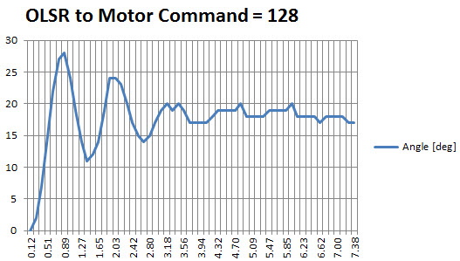

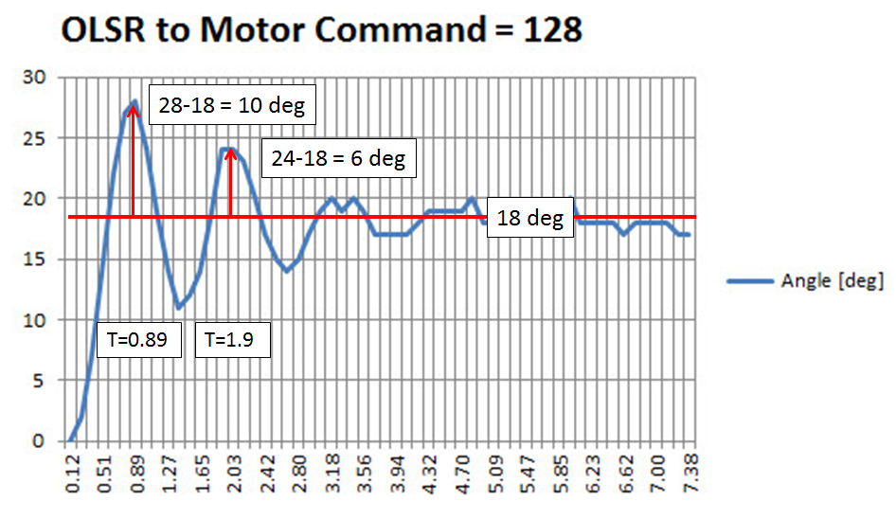

**Step 4:** From your plot, calculated the damping ratio and natural frequency. Note that the amplitudes are referenced from the steady-state angle. Recall the 2 relationships:

(1A)

$$ln\frac{a}{b}=\frac{ζ2π}{\sqrt{1-ζ^{2}}}=\frac{1}{N}ln\frac{X_{1}}{X_{N+1}}$$

(1B)

$$\frac{2π}{T}=ω_{n}\sqrt{1-ζ^{2}}$$

Fig 1-1A (right) is a close up of the time response and identifies the following: $a=28-18=10, b=24-18=6, \text{and} T=1.9-0.89=1.01 \text{sec.}$ Substituting these values into (1A), one has:

$$ln\frac{10}{6}=0.51= \frac{ζ2π}{\sqrt{1-ζ^{2}}}$$

$${\left(0.51\sqrt{1-ζ^{2}}\right)}^{2}={\left(ζ2π\right)}^{2}$$

Solving for $ζ$ one has $0.26\left(1-ζ^{2}\right)=ζ^{2}4π^{2}$ or $0.26-0.26ζ^{2}=39.5ζ^{2}$ or ultimately:

(2A)

$$39.76ζ^{2}=0.26 \text{or }ζ=0.081$$

Substituting the damping ratio $ζ$ into (1B), yields the following

$$\frac{2π}{1.01}=ω_{n}\sqrt{1-{0.081}^{2}}$$

$6.22=ω_{n}\sqrt{0.993} \text{or }ω_{n}=6.24$

(2B)

Substituting (3A) and (3B) into the general 2nd order dynamic equation (1) yields

$$\ddot{θ}+2\left(0.081\right)\left(6.24\right)\dot{θ}+{\left(6.24\right)}^{2}$$

$$θ ̈+1.01\dot{θ}+38.9=0$$

(3)

**Step 5:** Determine motor constant.

**Fig 1-1B** is a block diagram depiction relating the input (motor command) and output (angle)

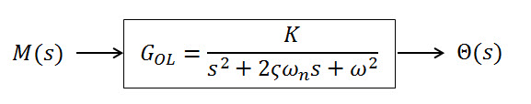

**Fig 1-1B**: Open loop transfer function

The DCP is represented by the open loop transfer function (OLTF) ${G(s)}_{OL}$ and relates the input $M(s)$, the motor command (a number between 0 and 255), and output named $Θ(s)$. Mathematically, one has:

(4)

$$\frac{Θ\left(s\right)}{M\left(s\right)}={G\left(s\right)}_{OL}=\frac{K}{s^{2}+2ζω_{n}s+ω_{n}^{2}}$$

Here, $K$ is an unknown constant that encompasses the properties of the motor, propeller, and the DCP’s moment of inertia, length, and lever arm distance. One can calculate $K$ as follows:

From (4) recognize that

(5)

$$\left(s^{2}+2ζω_{n}s+ω_{n}^{2}\right)Θ\left(s\right)=KM\left(s\right)$$

Or, in time domain, (5) becomes

(6)

$$\ddot{θ}+2ζω_{n}\dot{θ}+ω_{n}^{2}θ=Km\left(t\right)$$

At steady-state, the pendulum is motionless hence $\ddot{θ}=\dot{θ}=0$. From Fig 1-1A, the steady-state angle is $θ_{ss}=18$ degrees. Hence, with (2B), (6) becomes

$$0+0+{6.24}^{2}∙θ_{ss}=K∙m_{ss}$$

$$38.9∙18=K∙128$$

(7)

$$K=\frac{38.9∙18}{128}=\frac{700.2}{128}=5.47$$

With (7) and (3) the OLTF becomes

(8)

$${G\left(s\right)}_{OL}=\frac{5.47}{s^{2}+1.01θ+38.9}$$

**Step 6:** Simulate motorized DCP in Simulink or XCOS

**Fig 1-1C** depicts the OLTF (left) and response (right)

**Fig 1-1C:** XCOS modeling of a 128 step input command to the Lego-based motorized damped compound pendulum (left). Using the damping ratio, natural frequency, and gain $K$, a step response simulation can be run (right). This simulated plot of angle over time matches the experimental data shown in **Fig 1-1A**

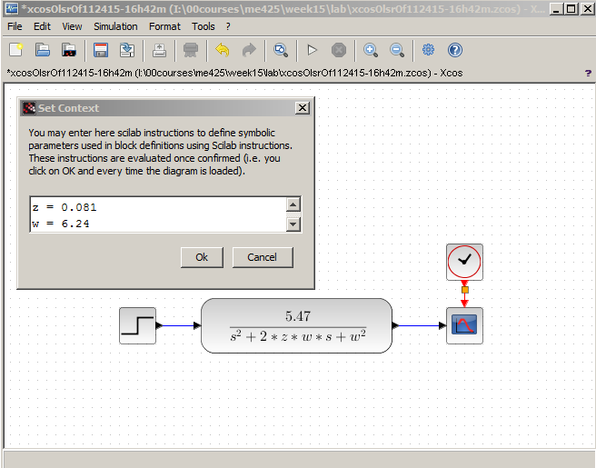

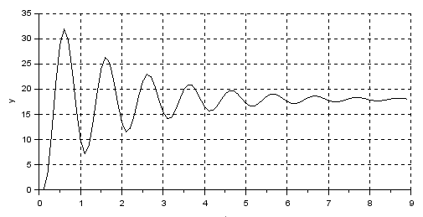

Recall, that the general solution for (4) is given by

(5A)



The complex roots are given by

(5B)



Substituting the values from (3A) and (3B) into (5B), that for the system captured in Fig 1-2A:

$$s_{1,2}=-\left(0.053\right)\left(4.42\right)±jω_{n}\sqrt{1-ζ^{2}}$$

$$s_{1,2}=-0.23±j4.42\sqrt{0.997}$$

(6)

$$s_{1,2}=-0.23±4.41j$$

From (6) one sees the real part of the complex roots is negative. Thus (5A) yields an exponentially decaying response; small values mean long settling times. The amplitude of oscillation is governed by imaginary values of the complex roots.

**Exercise**

* 1. Capture the time response of your motorized damped compound pendulum. Capture your plot (similar to Fig **1-2A** left).
  2. From your plot, identify the height of consequent peaks, and the time between peaks. Use these to calculate the damping ratio $ζ$ and natural frequency $ω_{n}$ for your system.
  3. From your damping ratio and natural frequency, calculate the characteristic equation i.e. (4) and the roots i.e. (6)

**Concept 2 – PID Simulation**

In Xcos (or Simulink) one can implement PID control with the DCP model:

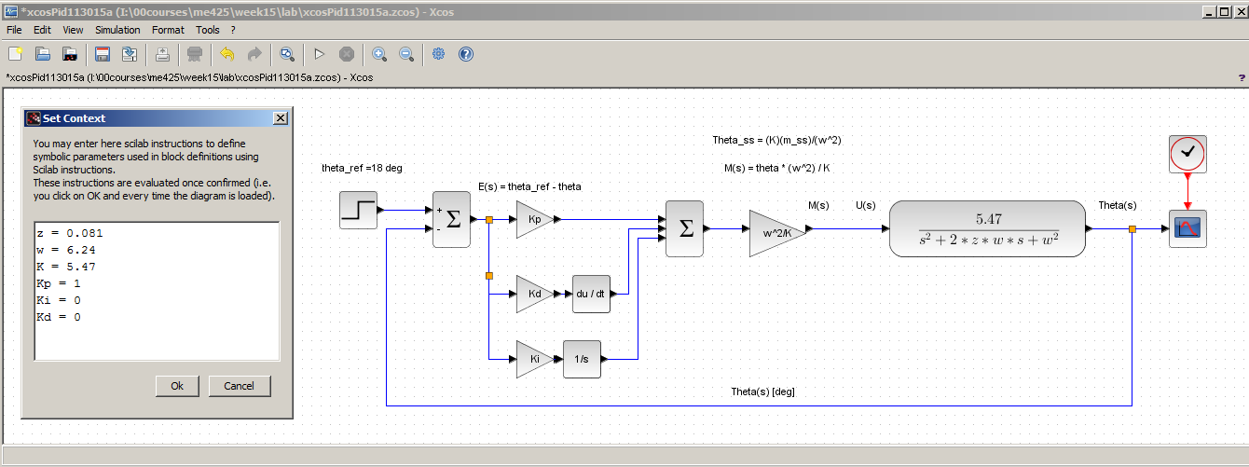

**Fig 2-1A:** Xcos implementation of damped compound pendulum Equation (7).   
Here, the context is set to z = 0.081, w = 6.24, K = 5.47, Kp = 1, Ki = 0, Kd = 0. The simulation was set to run for 15 seconds.

The DCP is a Type 0 system. In other words, there are no free integrators (s terms) in the denominator. Theory says that a step response into a Type 0 system has the following characteristics:

|  |  |  |  |
| --- | --- | --- | --- |
| Gain | Steady-State Error | Transient Response | Stability |
| Proportional | Always have error | Faster | Overshoot if 2nd order system |
| Integral | Zero error | Faster | Can go unstable |
| Derivative | Always have error | Slower | No overshoot if 2nd order system |

**Table 2-1:** Shows cause and effect of increasing P, I or D gains

**Fig 2-2A** shows plots that verify the above statements

**Fig 2-2B:** Various plots running simulation in Fig 2-1A.

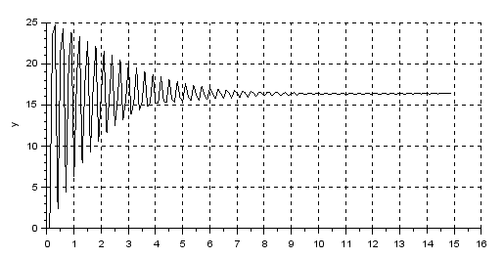

Kp = 10, Ki = 0, Kd = 0. $ϑ_{ss}=16\text{[deg]}$

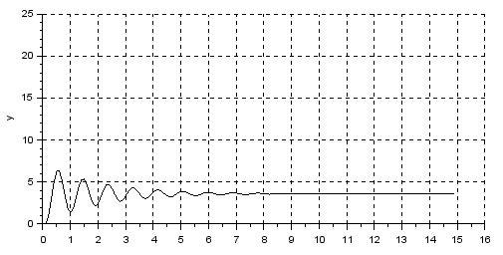

Kp = 0.25, Ki = 0, Kd = 0. $ϑ_{ss}=3\text{[deg]}$

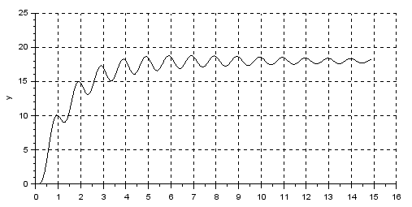

Kp = 0, Ki = 0.75, Kd = 0. $ϑ_{ss}=18\text{[deg]}$

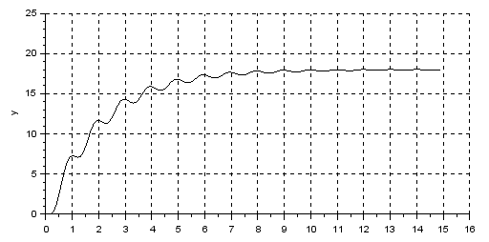

Kp = 0, Ki = 0.5, Kd = 0. $ϑ_{ss}=18\text{[deg]}$

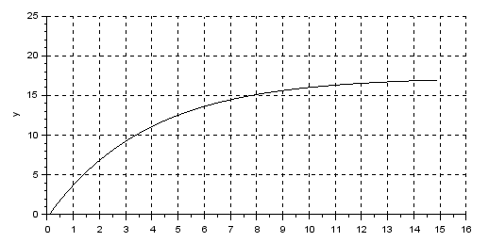

Kp = 25, Ki = 0.5, Kd = 100. $ϑ_{ss}≈18\text{[deg]}$

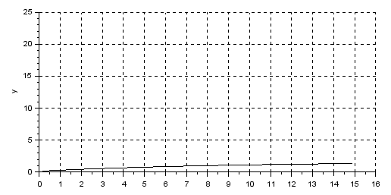

Kp = 0.1, Ki = 0, Kd = 10

**Exercise**

* 1. Replicate Fig 2-2B by simulating your system. Capture 6 plots: (1A) Proportional-only; (1B) Higher proportional-only; (2A) Integral-only; (2B) higher integral-only; (3A) proportional + derivative; (3B) higher proportional-derivative
  2. Produce 4 plots using various combinations of PID gains: (A) zero steady-state error, no overshoot; (B) zero steady-state error, faster transient response than (A) and overshoot allowed; (C) zero steady-state error, faster transient response than (A) and no overshoot allowed; (D) unstable response