Hands-on Lab

Lego Programming – NxC Sensors

This lab continues to add new statements in NxC by focusing on sensors. Specific concepts include: the infrared sensor; and ultrasonic sensor.

Concept 1 – Infrared Light Sensor (IR): Program the NxC to read the IR Light Sensor and display its value on the NXT Brick. The Lego Light sensor returns a value from 0 to 100 with lower values corresponding to darker colors.

Step 1: Click File – New. Click File – Save As and save in a directory e.g. “myPrograms” with the name “helloIrSensor”.

Step 2: Enter the following text

Code Example: helloIrSensor.nxc

// FILE: helloIrSensor.nxt
// DATE: 04/09/11
// AUTH: P.Oh
// DESC: Read IR sensor (connected to Port 3) and display value on Brick's LCD

task main() {

int irSensorValue; // value read by IR sensor
string strIrSensorValue; // store integer value of IR sensor as string
string strMessageAndValue; // To display IR sensor value

SetSensorLight(IN_3);
// Described in Section 6.33.2.45 of NXT Guide. Returns void
// IN_3: input port 3

do {
irSensorValue = Sensor(IN_3);
// Described in Section 6.33.2.34 of NXT Guide
// Example in Section 9.639 of NXT Guide

strIrSensorValue = NumToStr(irSensorValue);
// Described in Section 6.65.2.14. Input is number. Returns string
// Example in Section 9.460 of NXT Guide

strMessageAndValue = StrCat("IR reads:", strIrSensorValue);
// Described in Section 6.65.2.18. Input is string. Returns string

TextOut(10, LCD_LINE4, strMessageAndValue);
Wait(100);

} while(true); // endless do-while loop

StopAllTasks();

} // end main

Step 3: Click File – Save All and then Compile.

Step 4: Execute the program by launching Compile – Download and Run. Shine your IR Light sensor on a gray pattern (either using a hardcopy printout or one displayed on your monitor). Your Brick should display a value between 0 and 100. Lower numbers represent darker shades.
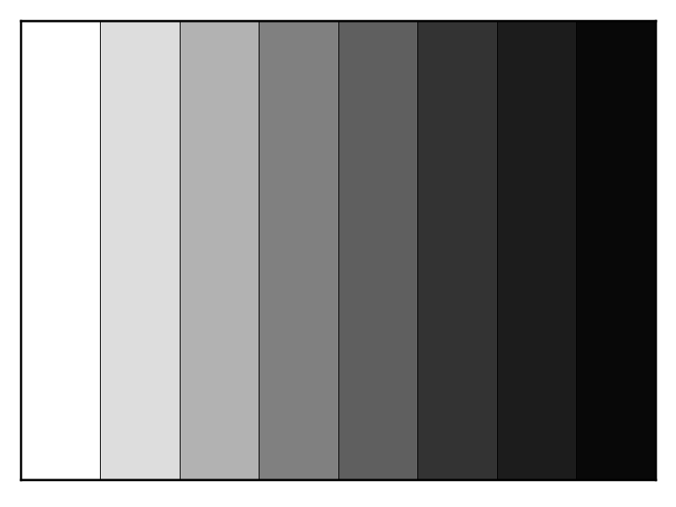
Figure: Shine your IR sensor on this pattern

Exercise 1: In NxC create programs for the following:

  - Use the NXT Guide to search for the PlayTone statement. Have your NXT play a scale where lower IR values (darker shades) are base and higher IR values (lighter shades) are treble.

Concept 2 – Ultrasonic Sensors: Program the NxC to read the Ultrasonic Sensor and display its value on the NXT Brick. Of particular note is that the Lego Ultrasonic Sensor employs an I2C bus connection. NxC enables one to connect to I2C-based sensors using the SetSensorLowspeed statement. Apparently the Lego Ultrasonic Sensor can report distances from 0 to 255 centimeters with ± 3 centimeters precision.

Step 1: Open a new file and save as “helloUsSensor.nxc”. Type the following and save
// FILE: helloUsSensor.nxt
// DATE: 04/11/11
// AUTH: P.Oh
// DESC: Read US sensor (connected to Port 4) and display value on Brick's LCD
// NOTE: US sensor uses I2C bus so need to use SetSensorLowspeed statement

task main() {

byte usSensorValue; // value read by US sensor (value from 0 to 255)
string strUsSensorValue; // store integer value of US sensor as string

string strMessageAndValue; // To display US sensor value

SetSensorLowspeed(IN_4);
// Described in Section 6.33.2.46 of NXT Guide. Returns void
// IN_4: input port 4

do {
usSensorValue = SensorUS(IN_4);
// Described in Section 6.42.2.22 of NXT Guide. Returns byte
// See also: Section 9.665

strUsSensorValue = NumToStr(usSensorValue);
// Described in Section 6.65.2.14. Returns string
// Example in Section 9.460 of NXT Guide

strMessageAndValue = StrCat("US reads:", strUsSensorValue, " ");
// Described in Section 6.65.2.18. Returns string

TextOut(10, LCD_LINE4, strMessageAndValue);
Wait(100);

} while (true); // endless do-while loop

StopAllTasks();

} // end main

Code Example: helloUsSensor.nxc – Displays Ultrasonic Sensor value (0 to 255)

Step 2: Attach the Lego Ultrasonic Sensor to Port 4 on the Brick

Step 3: Save All, Compile, then Download and Run

Step 4: Execute the program and see the displayed value change as distance to sensor changes.

Exercise 2: In NxC create programs for the following:

  - The Brick plays a sound scale in proportion to the distance to the Lego Ultrasonic Sensor

