Concept 3

In Step 1, the student is instructed to set the function generator to 200 Hz sine wave. The VI timer to set to 25 ms (i.e. 40 Hz sampling frequency). When the acquired data is plotted, one will not see a clean sinusoidal signal. Ask the students what may be wrong. Make them think and question themselves. Did they program the VI correctly? Were the proper screw terminals used?

Most likely there will find nothing wrong with the software or hardware. Next, ask them to think about Shannon’s Sampling Theorem. Ask them to tell you about aliasing. The theorem states that one must sample as least two times faster than the phenomena one wishes to measure. That is, a 200 Hz wave demands one to acquire data at a 400 Hz sampling frequency at a minimum. Practically speaking, one should acquire data 4 to 20 times faster. Hence, one should set the sampling frequency at 800 Hz (or 1.25 ms).

Tell the students to set the function generator to a 2 Hz sine wave and keep their VI as before (40 Hz sampling frequency). Here, Shannon’s Theorem is obeyed; one is sampling 20 times faster the phenomena. Once plotted, the students should see a clean sine wave.

Concept 3 – Exercise 3-3

To collect an 80 Hz signal, one should set the sampling theorem at least 320 Hz (four times the phenomena). This would demand a timer of 3.125 milliseconds. The VI timer only works with integers, so the student may be tempted to set the timer at 3 milliseconds. The plotted data will unlikely be sinusoidal. What is wrong? Ask the students to look at the first column of Excel data, which represents time. Is the data collected every 3 milliseconds? Most likely it is not.
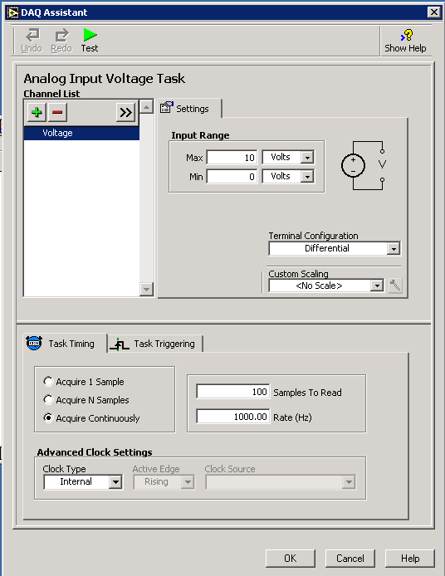
Explain that Windows is a slow operating system. The VI’s front panel has a numeric indicator that is supposed to display time. Windows’ screen refresh time is rather slow and cannot keep up with the demand to display elapsed time. Also, data must be written to the hard drive, which also takes up valuable time.

The correctly collect the 80 Hz signal (or faster), one should change the properties for the analog input channel. In DAQ Assistant (see left), change “Acquire one sample”, to “Acquire Continuously” and input 320 Hz in the “Rate” input box. One should also eliminate the VI timer, while loop and numeric indicator from the front panel.

Run the VI continuously for about 5 seconds and then click stop. Plotting the data should reveal a nice clean 80 Hz sine wave.

Moral: When acquiring data, one must obey Shannon’s sampling theorem and consider if the hardware is fast enough to acquire data at the desired rate.

