**Hands-on Lab:**

**LabVIEW – System Identification**

The LEGO Damped Compound Pendulum (DCP) is an example of a second order system. Using the previous Angle Sensor lab, one can measure the DCP’s free fall response. As a pendulum, the oscillations will exponentially decrease. One can then calculate the damping ratio and damped natural frequency. This results in system identification, namely to determine the DCP’s characteristic equation and consequently, the transfer function.

**Concept 1:** **DCP Step Response Testing**

**Step 1:** Create Front Panel and Initial Block Diagram

From your Angle Sensor lab open the file nxtLabviewEncoderGraphTest1_2.vi. Recall that you wrote this file in Exercise 2-2. This Labview program consisted of a waveform chart, an XY chart, and wrote angle data every 25 milliseconds to a CSV file.

Save this file as nxtLabviewLegoDcpSystemId1_0.vi.

Add a toggle switch (MINDSTORMS Robotics – Boolean – Vertical Toggle Switch) to the Front Panel and add text to this switch (**Figure 1A left**). Right click this switch to make sure that the Mechanical Action is set to Switch When Pressed. In the Block Diagram, drag the toggle switch so that it is inside the while-loop (**Figure 1A right**).

**Figure 1A:** Toggle switch show in Front Panel (left) and inside while-loop of Block Diagram (right)

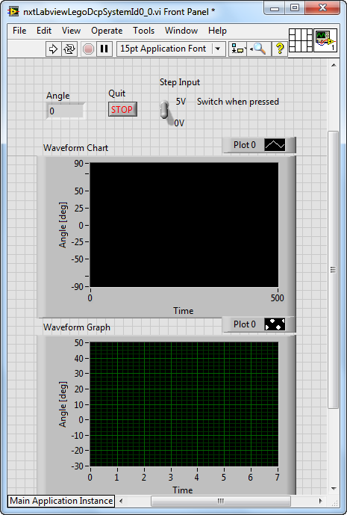

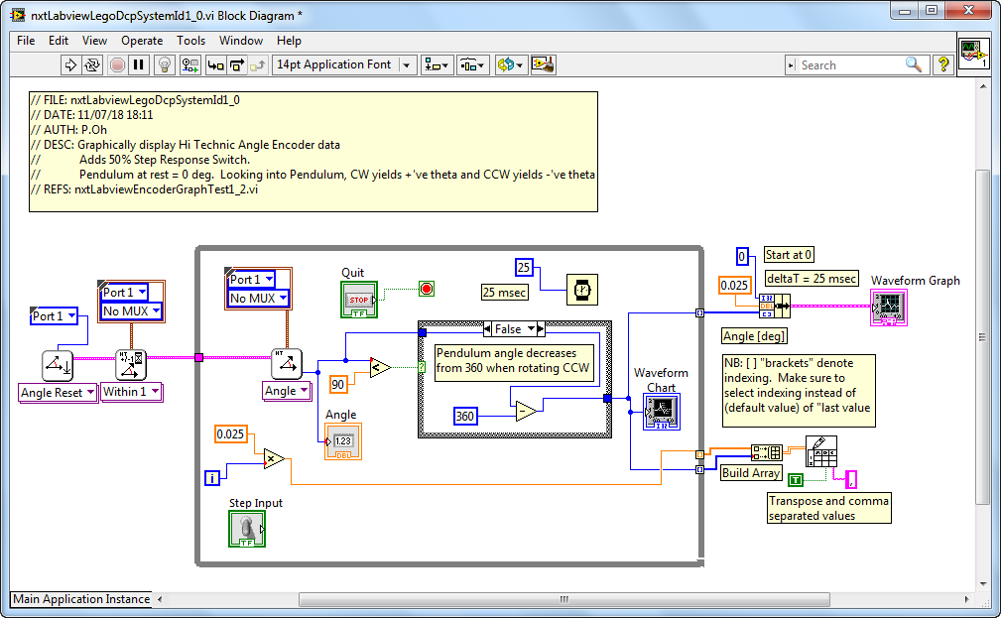

**Step 2:** Add a Motor Block to the Block Diagram

The toggle switch serves as a step input to the motor; when flipped on, a 50% motor power command will be fed into the motor. To achieve this, first add the NXT motor block (MINDSTORMS Robotics – I/O – Move Motors) into the while-loop. By default LEGO Mindstorms calls this block Power. Right click on the Power block and select Create Constant. Hovering over the created constant, select NXT Motor 1 (**Figure 2A**).

**Figure 2A:** Motor added to block diagram (called Power) with constant NXT Motor 1 as the assigned port.

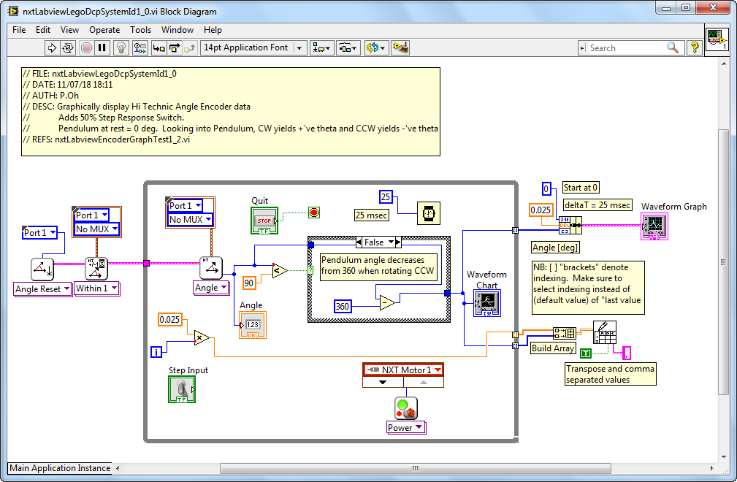

Next, place a Case Structure between the toggle switch and motor. For the True condition, add a numeric constant. Set this constant to 50, and wire it thru the Case Structure and into the motor’s Power input (**Figure 2B**).

For the False condition, add a numeric constant with the value of 0. Wire this constant to the Case Structure (**Figure 2C**). The net effect is when the Labview program is played toggling the switch will set the Case Structure to True and consequently issue a value of 50 into the motor power (and thus activating the motor). Conversely, when the switch is False, 0 is fed into the motor power (essentially deactivating the motor).

Save your program (called nxtLabviewLegoDcpSystemId1_0.vi).

**Figure 2B:** A Case Structure is added into the Block Diagram. For the True condition, the numeric constant is fed into the input of the motor (Power block). The toggle switch is wired to the Case Structure.

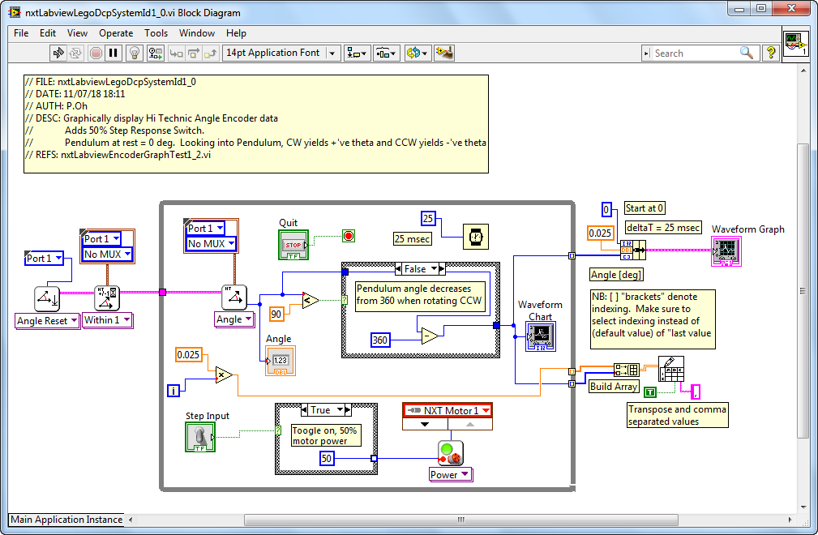

**Figure 2C:** For the Case Structure’s False condition, a numeric constant of zero is fed into the motor input (Power block).

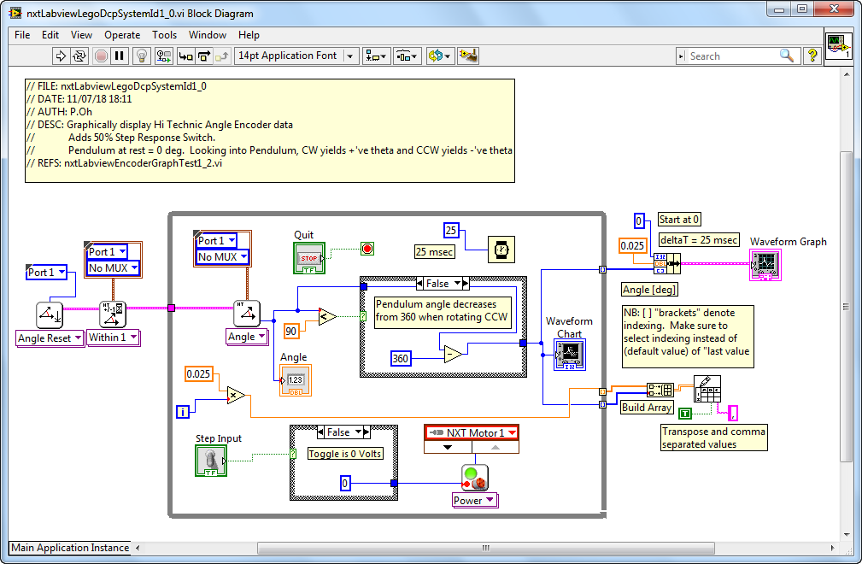

**Step 3:** Execution

A step response will be performed on the LEGO DCP (see **Figure 3A**). The above block diagram shows the angle sensor and motor connections. Thus, connect your NXT cable from the Hi Technic Sensor to the Port 1 of the NXT and your spliced NXT cable to Port A of the NXT.

Since this program will activate the motor-prop, make sure to clear any obstacles the pendulum could possibly hit. Execute the program (nxtLabviewLegoDcpSystemId1_0.vi) and observe the waveform chart. Toggling on the switch will send 50% power to the motor and the pendulum will start to rotate clockwise. Toggling off the switch stops the motor. Repeat toggling on and off to ensure the LEGO DCP and your program is working as expected (**Figure 3B**).

Hit the front panel’s Stop button. A pop up box will prompt you to enter a file name. For example, saving as systemId-110918-07H41M.csv suggests the data was saved on 11/09/18 and 7:41 AM as comma-separated values (CSV) file format.

Opening this CSV file with Excel and plotting the values (**Figure 3C**) yields what was captured and displayed on the front panel’s XY chart

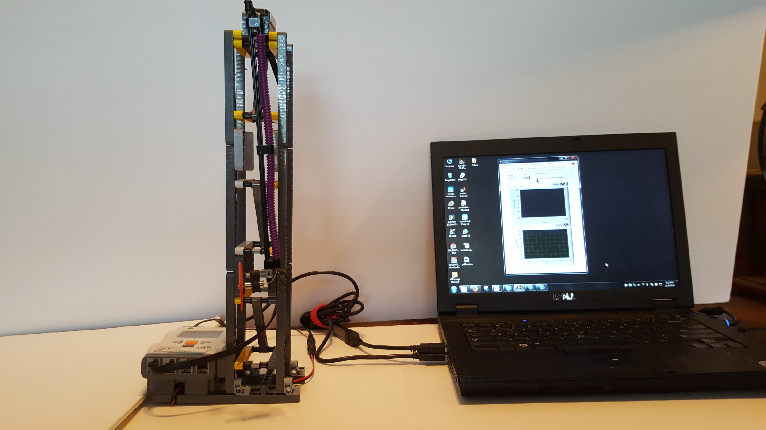

**Figure 3A:** LEGO DCP connected to laptop. Note: no obstacles in the pendulum’s pathway. Angle sensor and Motor are connected to the Brick’s Port 1 and Port A respectively.

**Figure 3B:** Sequential photos from a video. Top Row: Program is executed (left); pendulum at rest (middle); and switch toggled on and activates motor-prop (right). Bottom Row: motor-prop generates thrust which raises pendulum and waveform chart provides real-time display of angle (left); toggling motor off, stops motor and pendulum returns to zero angle position (middle); toggling switch on again raises pendulum and waveform chart shows angle response (right).

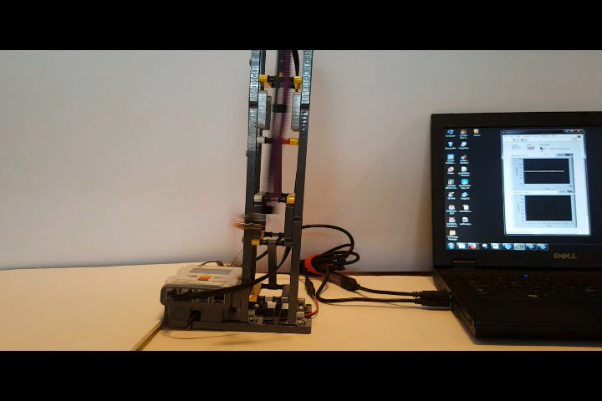

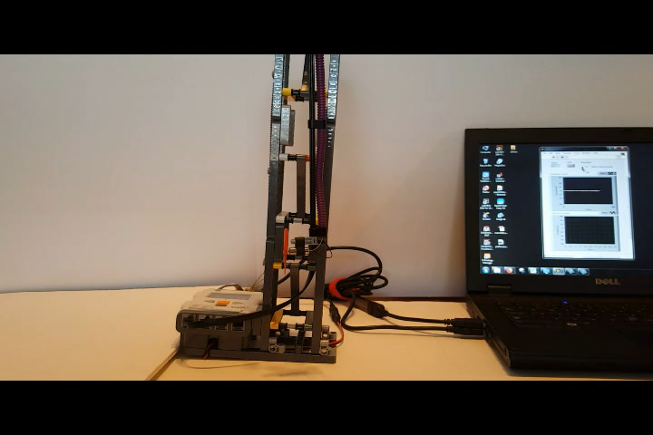

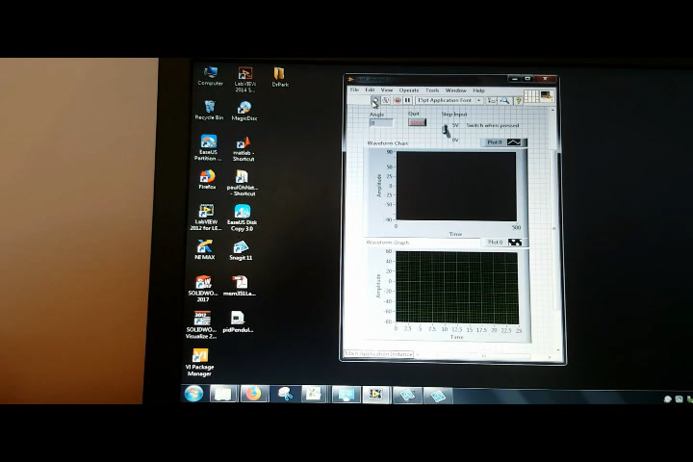

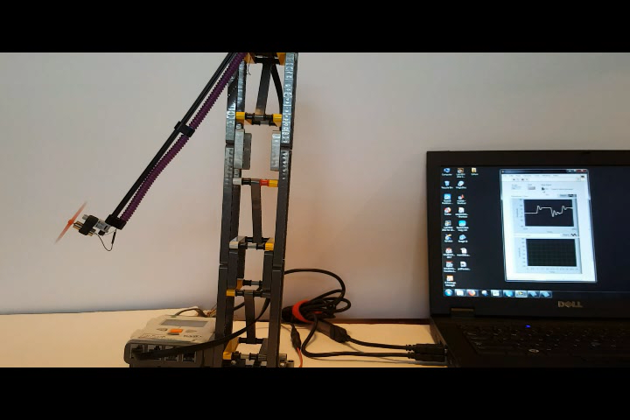

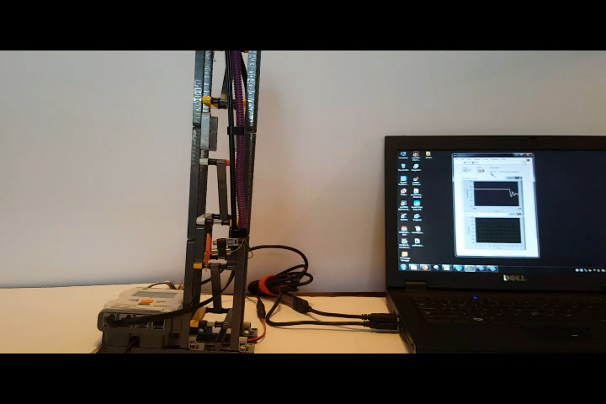

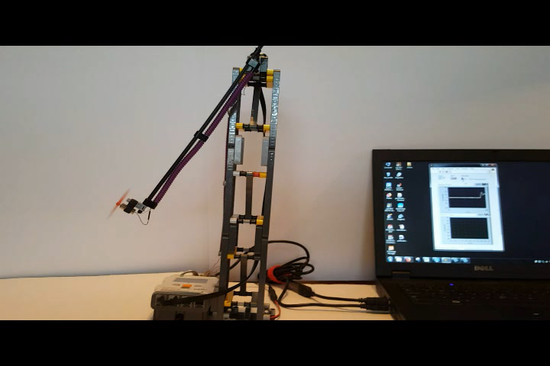

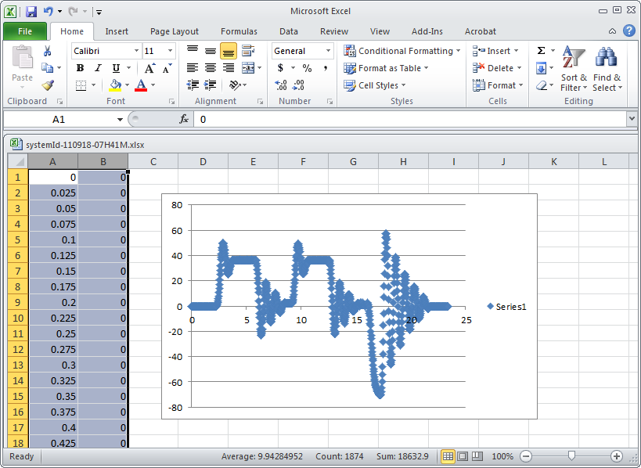

**Figure 3C:** Opening the CSV file in Excel, and performing a scatter plot, shows the LEGO DCP’s angular response to a step input. One sees (around 2.5 seconds) that apply 50% motor power (due to toggling the switch on), has the pendulum reach a peak angle (about 50 degrees) and oscillates to reach a steady-state angle of about 35 degrees.

**Concept 2:** Free fall data capture and Logarithmic Decrement

Pendulums, like the LEGO DCP, when released from an initial angle, will oscillate. The oscillations’ amplitudes become smaller as the pendulum swings back-and-forth, until the finally stop. This is a characteristic of damped second-order systems like the LEGO DCP. The amplitudes and period are related to the system’s damping constant and damped natural frequency. This relationship will be shown in this concept. Such system identification serves to find a mathematical model (called transfer function) of the system (i.e. plant).

**Step 1:** Execute nxtLabviewLegoDcpSystemId1_0.vi

Here, toggling will not be used. Instead, run the program and move the pendulum to an initial angle (e.g. 45 degrees) and release (Figure 2A). Once the pendulum is motionless, hit the Stop button and save the data e.g. legoDcpFreefall-110918-XXX.csv.

Step 2: Plot the free fall data

Step 3: Calculate the damping ratio and damped natural frequency

**Concept 3:** Simulink Modeling

Open your nxtLabviewSensorTest1_0.vi from Concept 1 and save it as a new program called nxtLabviewSensorTestAndGraph1_0.vi. Add a Waveform Chart into the Front Panel and the block into the while-loop (**Figure 1A**). Label the chart’s Y-axis and Angle [deg] and set its range to -90 to +90.

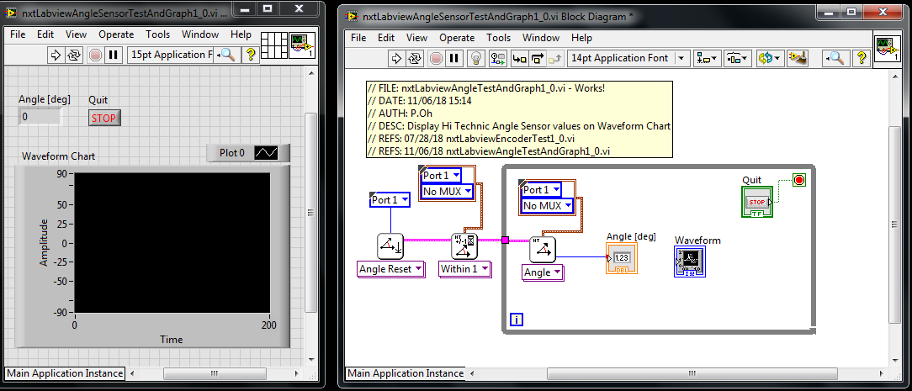

**Figure 1A:** Front Panel and Block Diagram with Waveform Chart

**Step 2:** Add Case Structure

Let’s configure the data such that the angle increases (from zero) for clockwise (CW) rotations and decreases (negatively) for counter-clockwise (CCW) rotations. To do so, add a Case Structure into the While-Loop (**Figure 2A**).

For angles less than 180, no changes are needed. This is reflected with the True condition (**Figure 2B**).

For CCW rotations, let the angle decrease. If the angle decreases past its initial value, then let the values be negative. This is reflected with the False condition (**Figure 2B**).

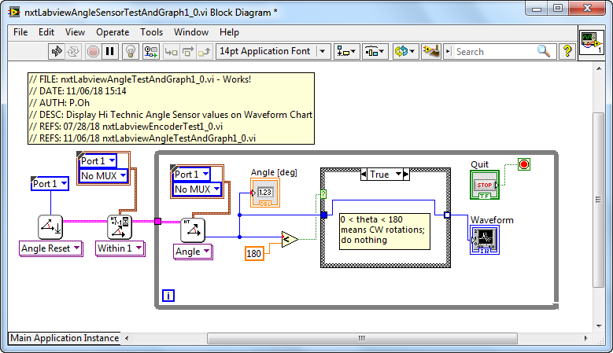

**Figure 2A:** Case Structure and True Condition for clockwise rotations

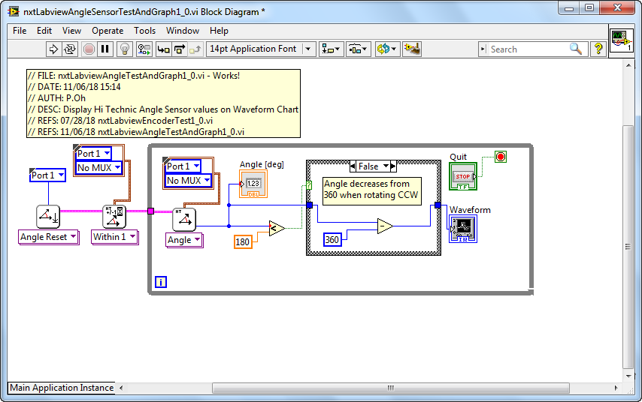

**Figure 2B:** Case Structure and False Condition for counter-clockwise rotations

**Step 3:** Execution

Running the program nxtLabviewSensorTestAndGraph1_0.vi should show angle changes in the Waveform Chart (Figure 3). At run-time, the angle is 0 degrees. CW rotations increase positively. CCW rotations decrease and when they go past the initial axle position become negative.

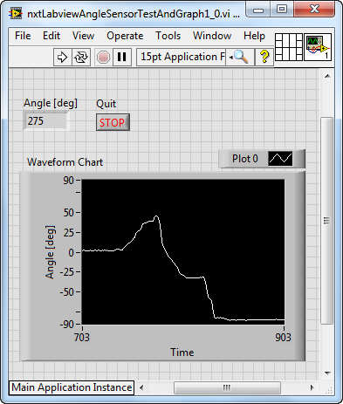

**Figure 3:** At execution, the angle is zero. Rotating the axle CW increases the angle (to about 50 degrees). CCW rotations show a decrease in angle. Once CCW rotations of the axle pass the zero point, they become more negative (about -85 degrees).

**Exercise 2:** In Labview create programs to:

* 1. Expand upon nxtLabviewSensorTestAndGraph1_0.vi to include an XY Graph timed at 25 milliseconds. Call this program nxtLabviewEncoderGraphTest1_1.vi
  2. Expand upon 2-1 to add saving of data to a CSV file. Call this program nxtLabviewEncoderGraphTest1_2.vi

A screenshot of Exercise 2-2 (nxtLabviewEncoderGraphTest1_2.vi) Front Panel and Block Diagram are given in **Figure 4A**. This program was tested with a pendulum attached to the axle in the Angle Sensor. The resulting CSV file is plotted in Excel (**Figure 4B**), showing the decaying amplitudes of this pendulum.

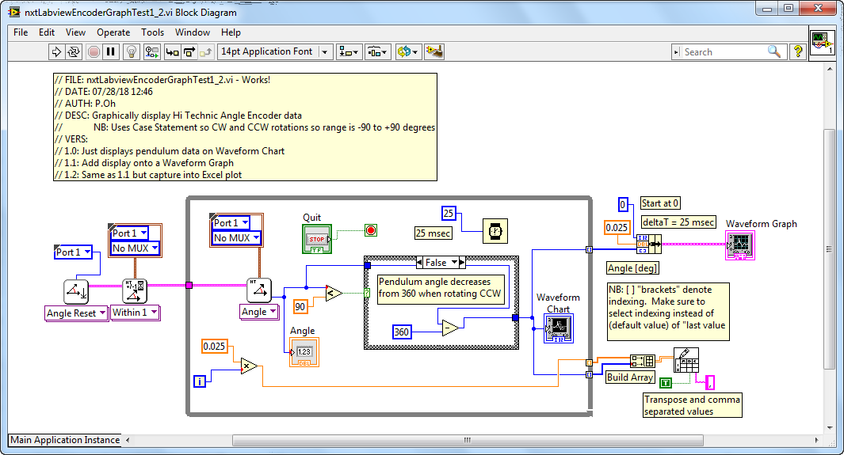

**Figure 4A:** Block diagram for nxtLabviewEncoderGraphTest1_2.vi

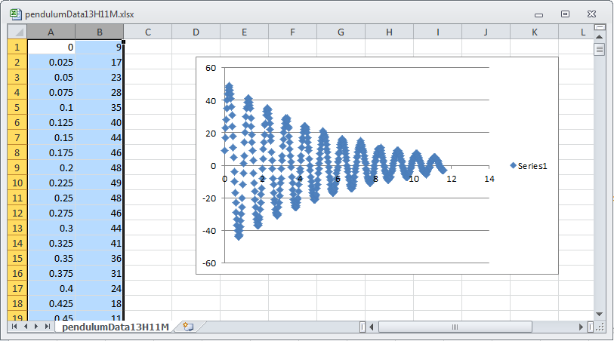

**Figure 4B:** One can attach a LEGO-based pendulum to the axle in the Hi Technic Angle Sensor. The above is an Excel plot of the resulting CSV file captured from nxtLabviewEncoderGraphTest1_2.vi