**Hands-on Lab:**

**LabVIEW – System Identification**

The LEGO Damped Compound Pendulum (DCP) is an example of a second order system. Using the previous Angle Sensor lab, one can measure the DCP’s free fall response. As a pendulum, the oscillations will exponentially decrease. One can then calculate the damping ratio and damped natural frequency. This results in system identification, namely to determine the DCP’s characteristic equation and consequently, the transfer function.

**Concept 1:** **Add Step Input Switch and Motor Control**

**Step 1:** Create Front Panel and Initial Block Diagram

From your Angle Sensor lab open the file nxtLabviewEncoderGraphTest1_2.vi. Recall that you wrote this file in Exercise 2-2. This Labview program consisted of a waveform chart, an XY chart, and wrote angle data every 25 milliseconds to a CSV file.

Save this file as nxtLabviewLegoDcpSystemId1_0.vi.

Add a toggle switch (MINDSTORMS Robotics – Boolean – Vertical Toggle Switch) to the Front Panel and add text to this switch (**Figure 1A left**). Right click this switch to make sure that the Mechanical Action is set to Switch When Pressed. In the Block Diagram, drag the toggle switch so that it is inside the while-loop (**Figure 1A right**).

**Figure 1A:** Front Panel (left) and Block Diagram (right) shows the controls the while-loop.

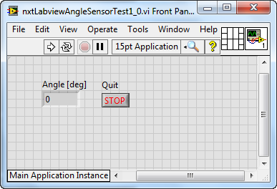

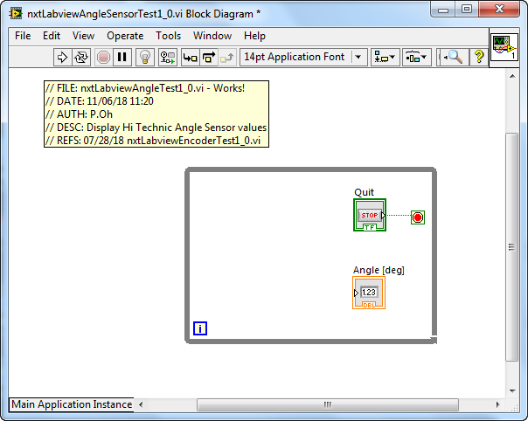

**Step 2:** Add a Motor Block to the Block Diagram

The toggle switch serves as a step input to the motor; when flipped on, a 50% motor power command will be fed into the motor. To achieve this, first add the NXT motor block (MINDSTORMS Robotics – I/O – Move Motors) into the while-loop. By default LEGO Mindstorms calls this block Power. Right click on the Power block and select Create Constant. Hovering over the created constant, select NXT Motor 1 (**Figure 2A**).

**Figure 2A:** Add HT Read block (left) into the while-loop. Right click this block (middle) and select Angle (right)

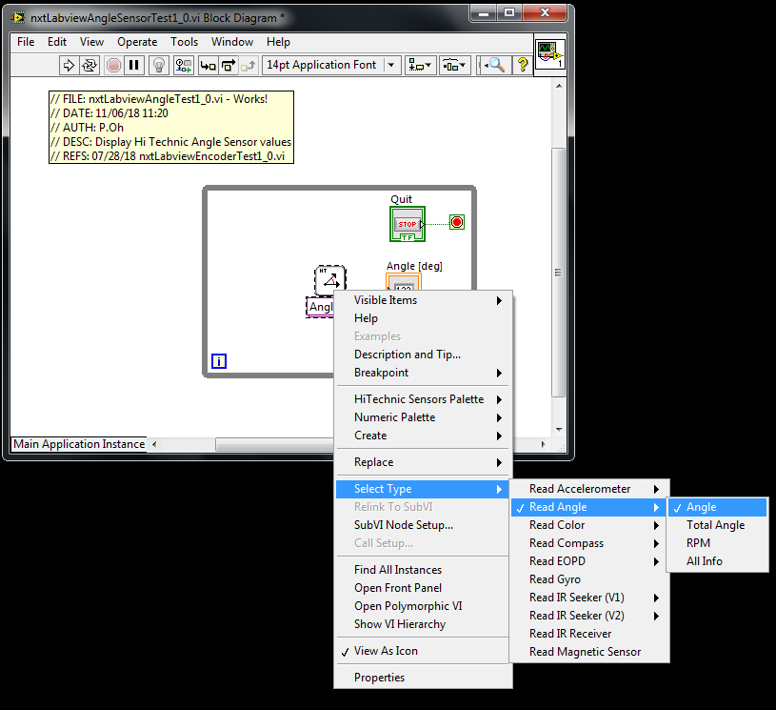

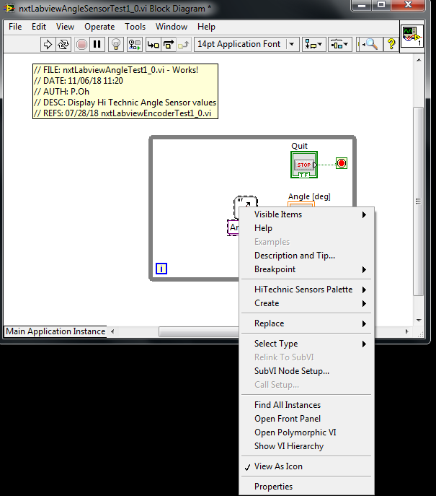

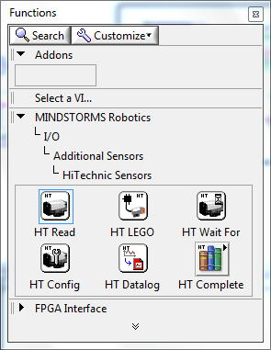

Next, place a Case Structure between the toggle switch and motor. For the True condition, add a numeric constant. Set this constant to 50, and wire it thru the Case Structure and into the motor’s Power input (**Figure 2B**).

**Figure 2B:** Right clicking the HT Read block (left) allows one to create a constant. By default, LEGO Labview sets this constant to Port 1 (right).

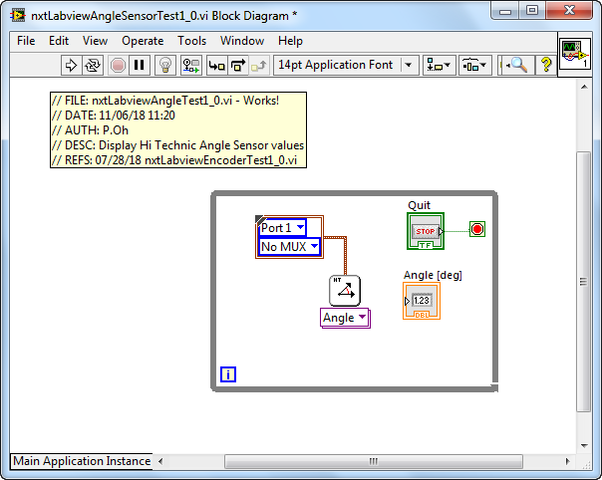

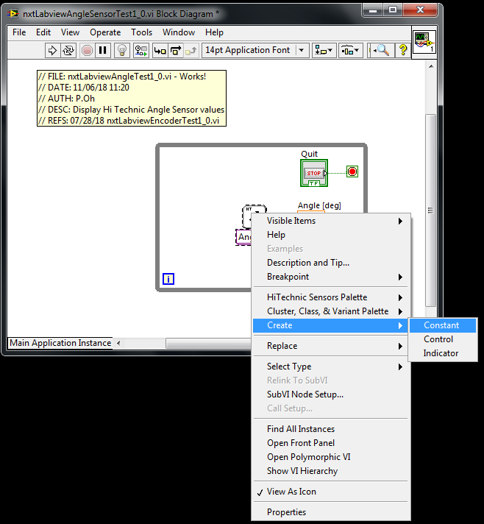

For the False condition, add a numeric constant with the value of 0. Wire this constant to the Case Structure (**Figure 2C**). The net effect is when the Labview program is played toggling the switch will set the Case Structure to True and consequently issue a value of 50 into the motor power (and thus activating the motor). Conversely, when the switch is False, 0 is fed into the motor power (essentially deactivating the motor).

Again, right click on HT Read (**Figure 2B left**) chose Create and click on Constant. By default, this sets the block is Port 1 (**Figure 2B right**). Note, the block switched from HT Read to being called Angle.

**Step 3:** Setup HT Config block

Next, add a Hi Technic Config (HT Config) block (MINDSTORMS Robotics – Programming – I/O – Additional Sensors – Hi Technic Sensors – HT Config) outside the while-loop (**Figure 3A left**). Note the HT Config block is called Angle Reset. Labview Mindstorms automatically recognized that you are working with Angle Sensors. If one clicks Angle Reset down arrow, one can verify that that Reset Angle is checked (**Figure 3A right**). This ensures that each time the program is executed the Angle is set to zero degrees.

**Figure 3A:** Drag a HT Config block outside the while-loop (left). LEGO Labview automatically names this block as Angle Reset. Right clicking this block allows one to verify that that Reset Angle is checked (right)

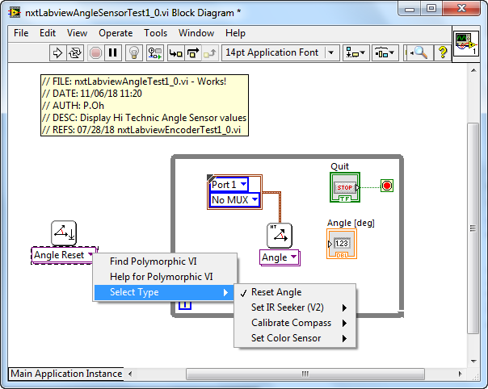

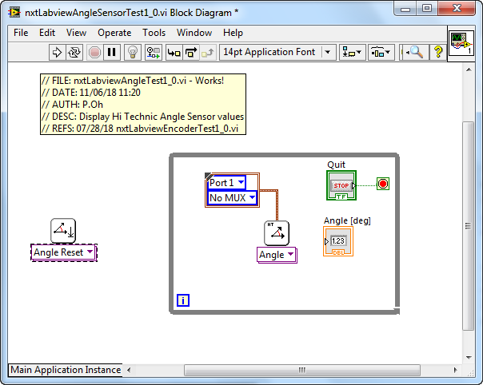

Hover near the top of the Angle Reset block and right click. Select Create – Constant (**Figure 3B left**). By default, Labview Mindstorms sets this constant to Port 1 (**Figure 3B right**).

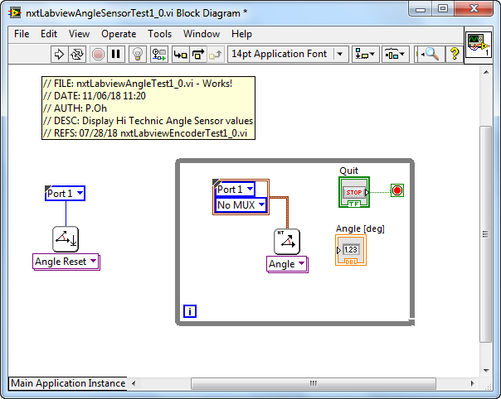

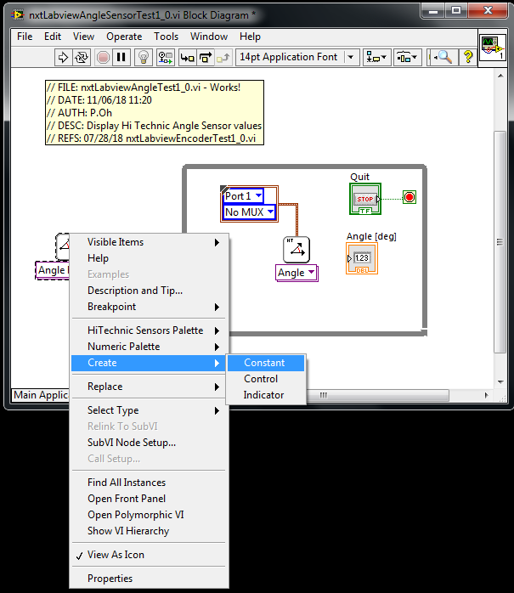

**Figure 3B:** Right clicking the Angle Reset block allows one to create a constant (left). LEGO Labview automatically sets this constant to Port 1 (right).

**Step 4:** Setup HT Wait For block

Add a Hi Technic Wait For (HT Wait For) block (MINDSTORMS Robotics – Programming – I/O – Additional Sensors – Hi Technic Sensors – HT Wait For) outside the while-loop (**Figure 4A left**).

Right click this block and choose Select Type – Wait For Angle – Value – Within 1 Degree (**Figure 4A right**). Labview automatically renames this block as Within 1.

**Figure 4A:** Drag a HT Wait For block in-between the Angle Reset and while-loop (left). Right clicking this block will allow one to configure the angle sensor to yield data if rotations are within 1 degree (right).

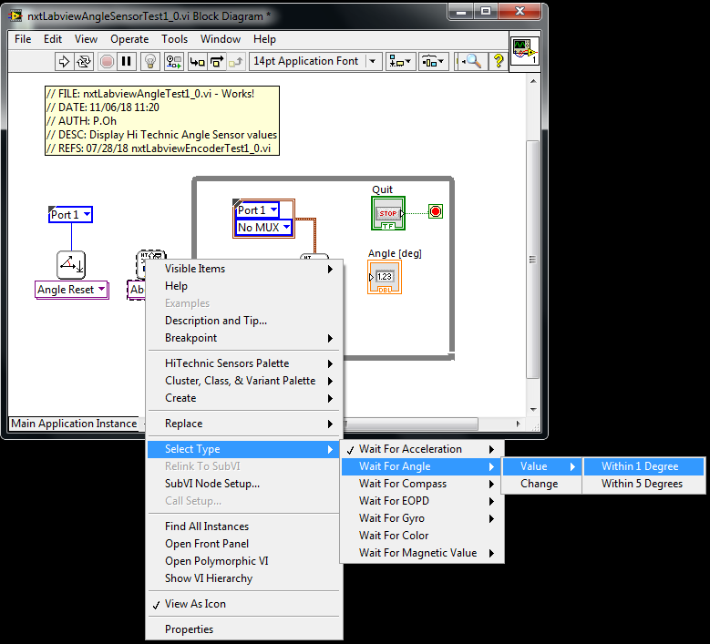

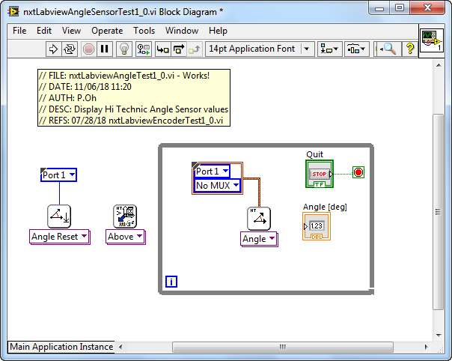

Hover near the top of this Within 1 block and choose Create – Constant (**Figure 4B left**). By default, Labview configures this for Port 1 (**Figure 4B right**).

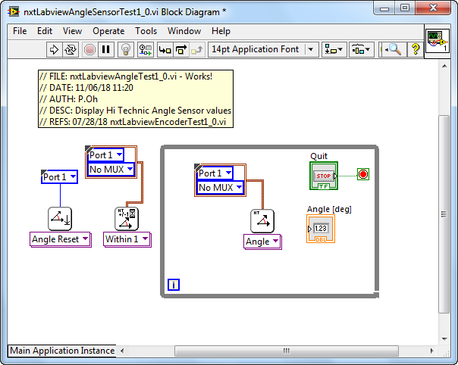

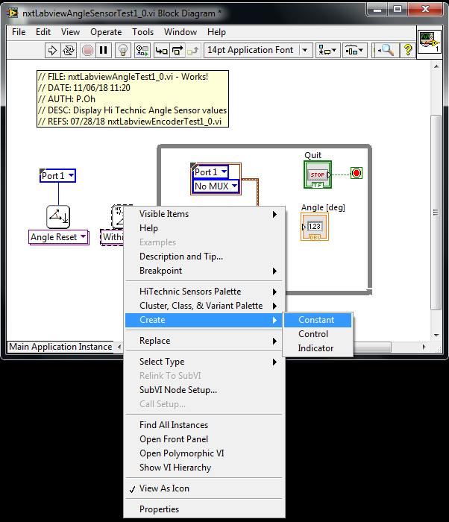

**Figure 4B:** Hovering over the HT Within 1 block and right clicking, allows one to create a constant (left). By default LEGO Labview sets this constant to Port 1 (right)

**Step 5:** Complete Wiring and Execute

Refer to **Figure 5A** **left** and wire the Angle Reset and Within 1 blocks. Next, wire the output of the Within 1 block thru the While-Loop and into the Angle Block. The wire will be colored pink. This reflects that the connection involves LEGO related components. Lastly, wire the output of the Angle Block into the numeric indicator.

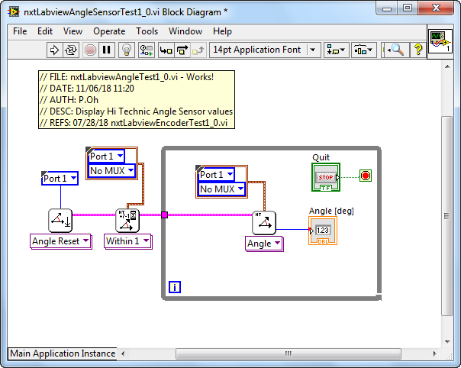

**Figure 5A:** Completed Block Diagram for nxtLabviewAngleSensorTest1_0.vi

Save your resulting file (from Step 1, it was named nxtLabviewAngleSensorTest1_0.vi). Connect a Hi Technic Angle Sensor into Port 1 of your NXT Brick. Insert a LEGO axle into the Angle sensor. Execute your program and rotate the axle. The numeric indicator should display the angle as you rotate the axle (**Figure 5B left and right**).

**Figure 5B:** nxtLabviewAngleSensorTest1_0.vi Front Panel (left) displays results of rotating axle that’s connected to the Hi Technic Angle Sensor (right). Sensor is attached to Port 1 of the NXT Brick.

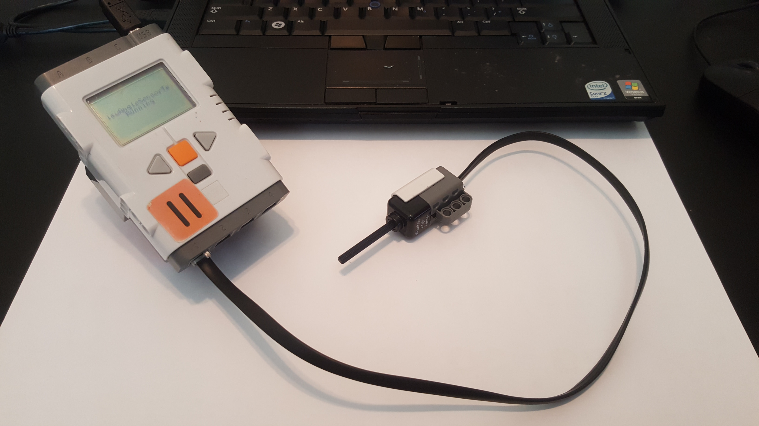

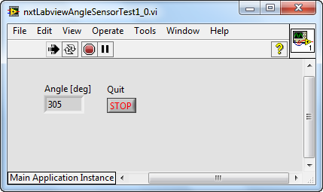

**Congratulations – You’ve Successfully Can Display Angle Sensor Data**

**Exercise 1:** In Labview create programs to:

1-1. Change nxtLabviewAngleSensorTest1_0.vi so that angular RPM is displayed in the numeric indicator (Hint: Right click on the Angle block and Select Type.

* 1. Same as before, but display RPM in a numeric gauge.
  2. Repeat nxtLabviewAngleSensorTest1_0.vi but configure to use Port 2

**Concept 2:** **Real-time Graphical Display of Angle Sensor**

In a previous lab, the Waveform Chart control was introduced. This chart allows one to display data as it is received by the sensor. This concept leverages the previous one to display real-time data from the Hi Technic Angle Sensor.

**Step 1:** Create Front Panel

Open your nxtLabviewSensorTest1_0.vi from Concept 1 and save it as a new program called nxtLabviewSensorTestAndGraph1_0.vi. Add a Waveform Chart into the Front Panel and the block into the while-loop (**Figure 1A**). Label the chart’s Y-axis and Angle [deg] and set its range to -90 to +90.

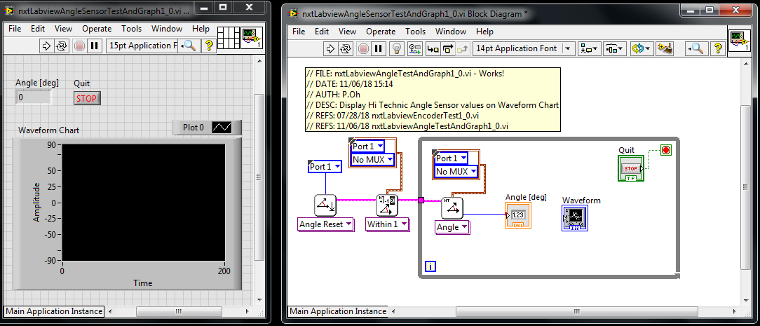

**Figure 1A:** Front Panel and Block Diagram with Waveform Chart

**Step 2:** Add Case Structure

Let’s configure the data such that the angle increases (from zero) for clockwise (CW) rotations and decreases (negatively) for counter-clockwise (CCW) rotations. To do so, add a Case Structure into the While-Loop (**Figure 2A**).

For angles less than 180, no changes are needed. This is reflected with the True condition (**Figure 2B**).

For CCW rotations, let the angle decrease. If the angle decreases past its initial value, then let the values be negative. This is reflected with the False condition (**Figure 2B**).

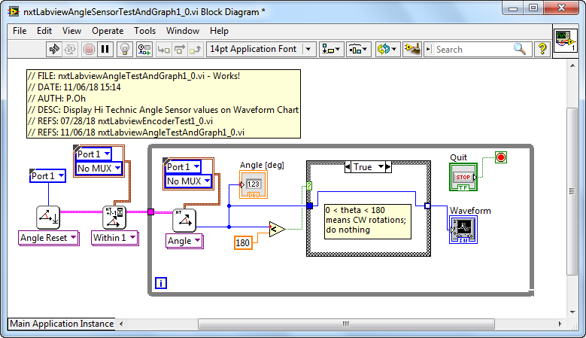

**Figure 2A:** Case Structure and True Condition for clockwise rotations

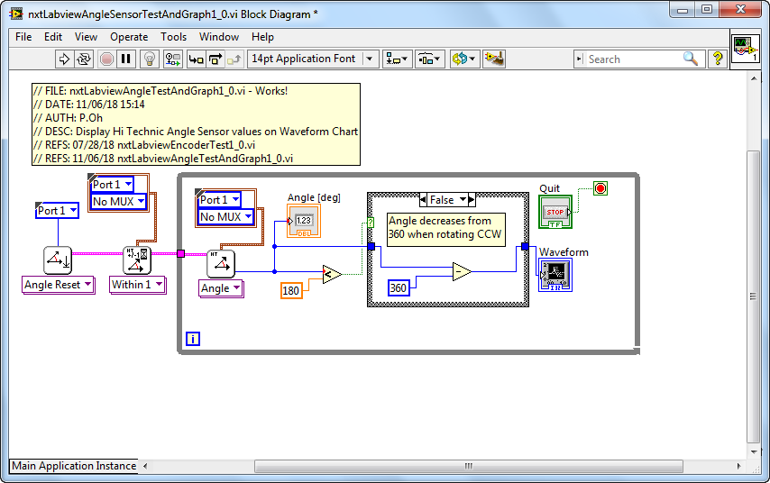

**Figure 2B:** Case Structure and False Condition for counter-clockwise rotations

**Step 3:** Execution

Running the program nxtLabviewSensorTestAndGraph1_0.vi should show angle changes in the Waveform Chart (Figure 3). At run-time, the angle is 0 degrees. CW rotations increase positively. CCW rotations decrease and when they go past the initial axle position become negative.

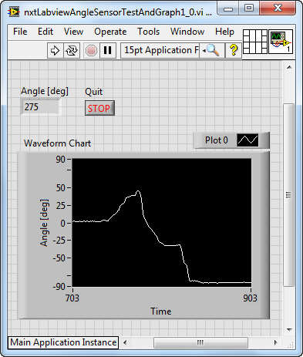

**Figure 3:** At execution, the angle is zero. Rotating the axle CW increases the angle (to about 50 degrees). CCW rotations show a decrease in angle. Once CCW rotations of the axle pass the zero point, they become more negative (about -85 degrees).

**Exercise 2:** In Labview create programs to:

* 1. Expand upon nxtLabviewSensorTestAndGraph1_0.vi to include an XY Graph timed at 25 milliseconds. Call this program nxtLabviewEncoderGraphTest1_1.vi
  2. Expand upon 2-1 to add saving of data to a CSV file. Call this program nxtLabviewEncoderGraphTest1_2.vi

A screenshot of Exercise 2-2 (nxtLabviewEncoderGraphTest1_2.vi) Front Panel and Block Diagram are given in **Figure 4A**. This program was tested with a pendulum attached to the axle in the Angle Sensor. The resulting CSV file is plotted in Excel (**Figure 4B**), showing the decaying amplitudes of this pendulum.

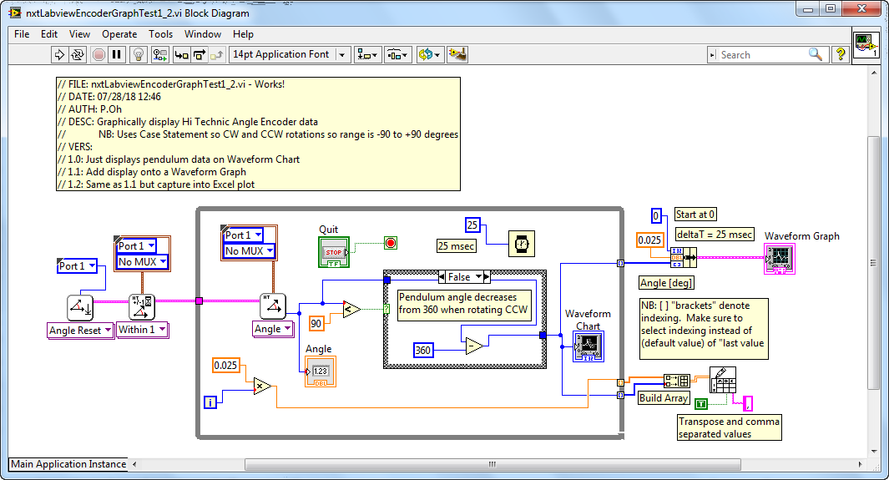

**Figure 4A:** Block diagram for nxtLabviewEncoderGraphTest1_2.vi

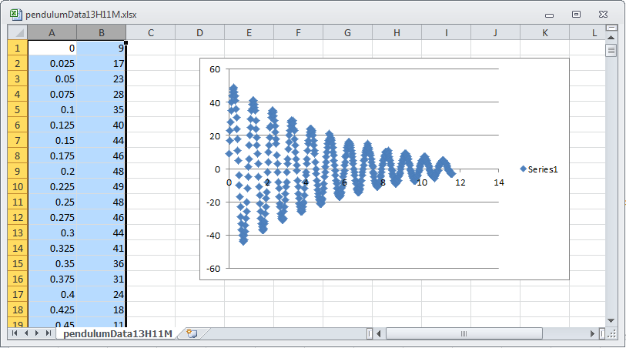

**Figure 4B:** One can attach a LEGO-based pendulum to the axle in the Hi Technic Angle Sensor. The above is an Excel plot of the resulting CSV file captured from nxtLabviewEncoderGraphTest1_2.vi