**Hands-on Lab 2:**

**LabVIEW – Virtual Power Supply**

Creating virtual instrumentation is the underlying strength of LabVIEW. One can easily create PC-based equipment like power supplies, function generators, data acquisition units and oscilloscopes. This requires interfacing one’s PC with peripherals that can input and/or output analog and/or digital signals. This lab demonstrates that the LEGO NXT can serve as such a peripheral.

# **Concept 1:** **Virtual Adjustable Power Supply** (Analog Voltage Output)

**Step 1:** Create Front Panel

Open LabVIEW, File – Save All with nxtLabviewVirtualPowerSupply1.0.vi. In your front panel, add a knob from the Controls Palette as seen in **Figure 1A**. Change default settings of the knob by right clicking it and selecting Properties (**Figure 1B**).

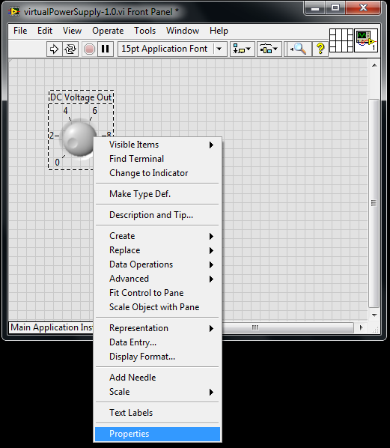

**Figure 1B:** Right click the knob and select Properties

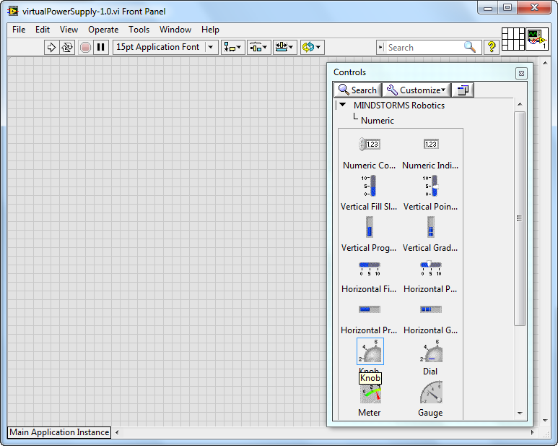

**Figure 1A:** Select knob from the Control Palette and drag into the front panel

Select Scale so that the maximum value is 5 (**Figure 1C**). You will eventually use the NXT Mindstorms brick to generate analog voltages. The brick uses six 1.5 Volt batteries. So the brick can deliver 6 Volts maximum, but you’ll limit it to 5 Volts.

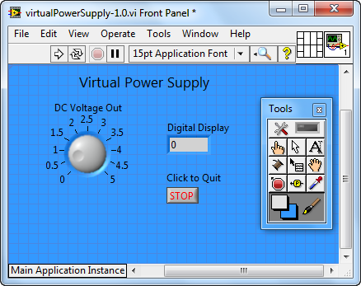

**Figure 1D:** Completed Front Panel

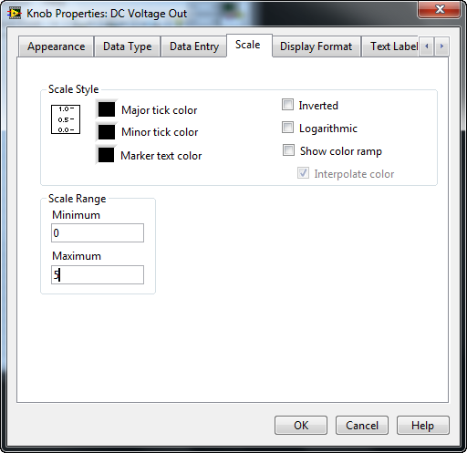

**Figure 1C:** Select Scale to change range

Complete your front panel with a numeric indicator and stop button (**Figure 1D**). Double-click on any empty space on the front panel, to add text (e.g. Virtual Power Supply). One can also change the front panel color (View – Tools Palette, Select the paint brush and color, and click on the front panel to fill it with that color).

**Step 2:** Create Block Diagram

Surround components with a While loop in your block diagram (recall: View – Functions Palette – Programming – Structures) as seen in **Figure 1E**. Complete component wiring as seen in **Figure 1F (left)**. Commenting is very important in programs. Use the Tools – Edit Text tool to add text in your Block Diagram.

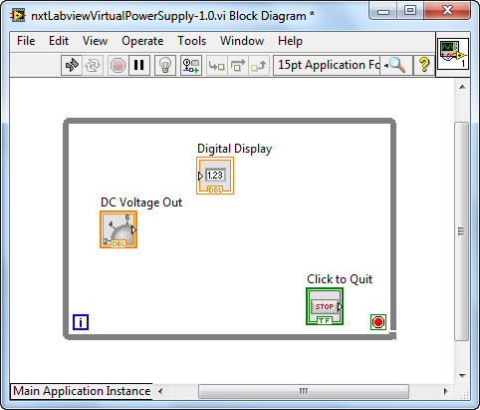

**Figure 1E:** Completed block diagram shows While loop surrounding components

Click Run on the front panel and adjust the knob. As seen in **Figure 1F (right)** the digital value of the knob is displayed in the numeric indicator box.

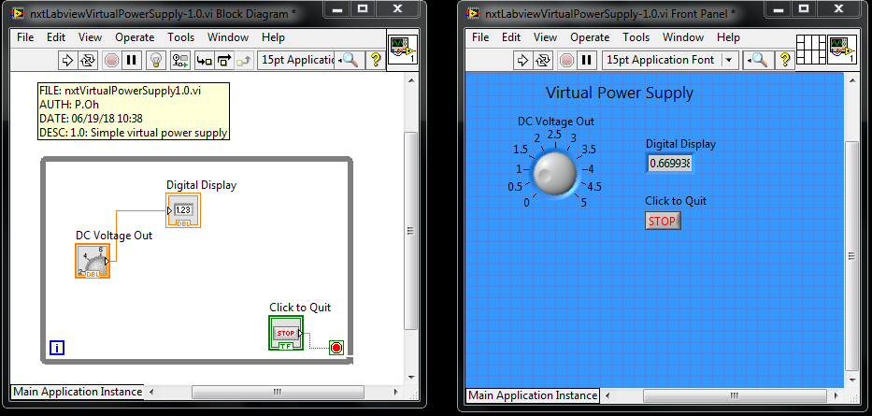

**Figure 1F:** Completed block diagram (left). Test by hitting Run and adjusting knob (right)

**Step 3:** Adding LEGO NXT components

As mentioned in the beginning of this lab, peripherals (physical devices that connect to a computer) are needed to input and/or output analog and/or digital signals. The NXT Mindstorms brick will serve as such a peripheral.

Add a Power control into the While structure of your block diagram. Click View – Functions Palette and select I/O and then Move Motors as seen in **Figure 1G**.

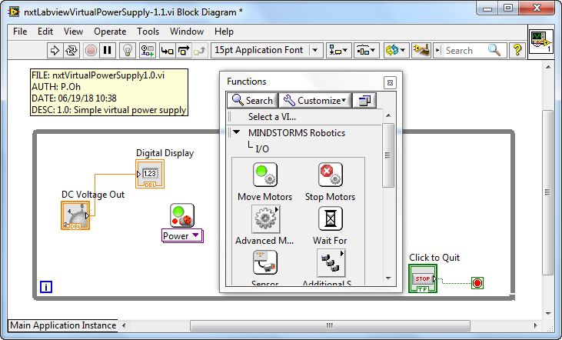

**Figure 1G:** The Power control was inserted into the While structure by selecting Move Motors from the Functions palette.

Hover your mouse near the top of the Power component. Right clicking will allow you to select “Create Constant” (**Figure 1H**). This adds an input to top of the Power control (**Figure 1I**). Right click on the created constant and select Configure (**Figure 1I**).

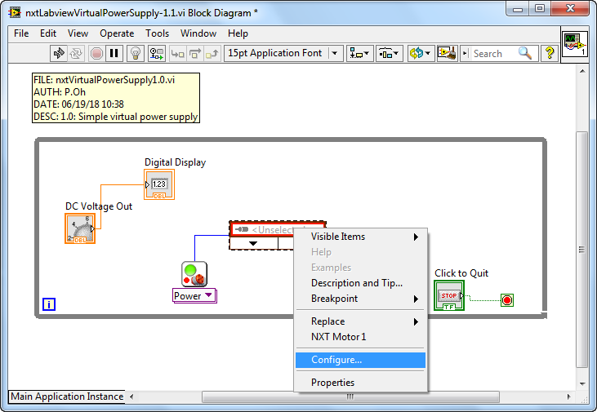

**Figure 1I:** Right click the created constant and select Configure.

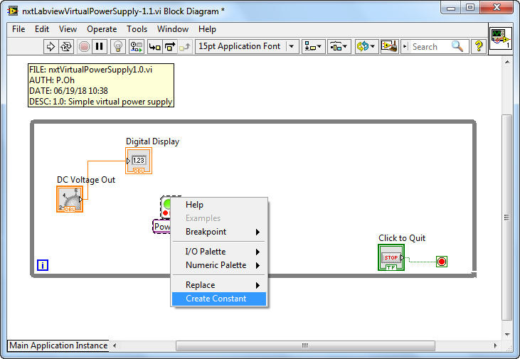

**Figure 1H:** Select Create Constant by hovering your mouse and right-clicking over the top of Power component

After clicking Configure, the Schematic Editor is launched as seen in **Figure 1J (left)**. One can now configure the various ports on the NXT brick. Click on the arrow for Port B and select NXT Motor. Under the Name field box, enter “Analog Voltage Out” to label Port B. Click on the arrow for Port A and chose “Open Port”. Repeat this for Port C. Make sure your brick is configured as seen in **Figure 1J (right)** and click Save and then Close.

**Figure 1J:** Schematic Editor (left) depicts the 3 motor (analog out) and 4 sensor (analog in) ports on an NXT brick. Port B is selected as a motor port with the name “Analog Voltage Out” (right).

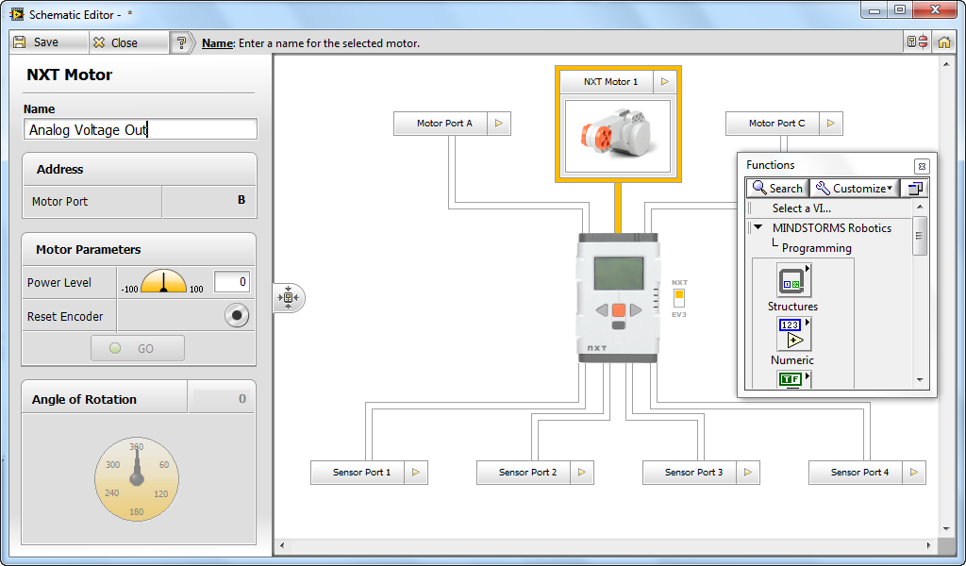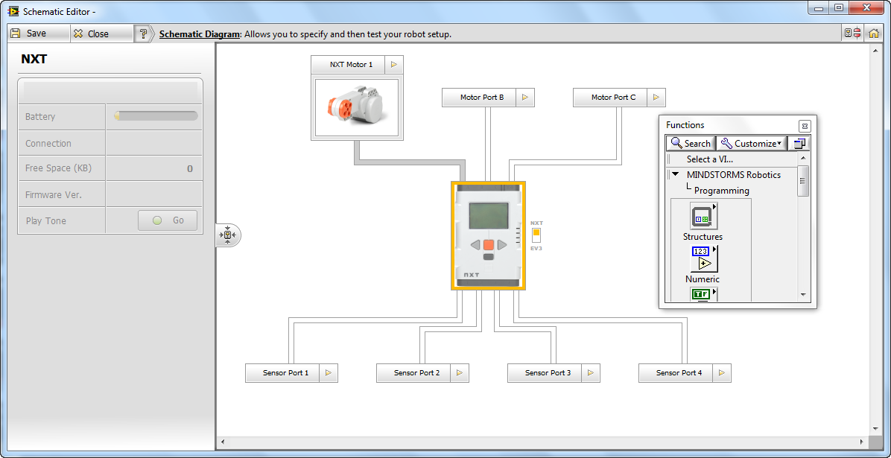

The Schematic Editor will close and return you to your block diagram. Right click your created constant and select “Analog Voltage Out”. Recall, this was the label you gave for Port B above. This will result in **Figure 1K**.

**Figure 1K:** Right-clicking the constant box allows on to select “Analog Voltage Out” (left). This then labels the constant accordingly (right).

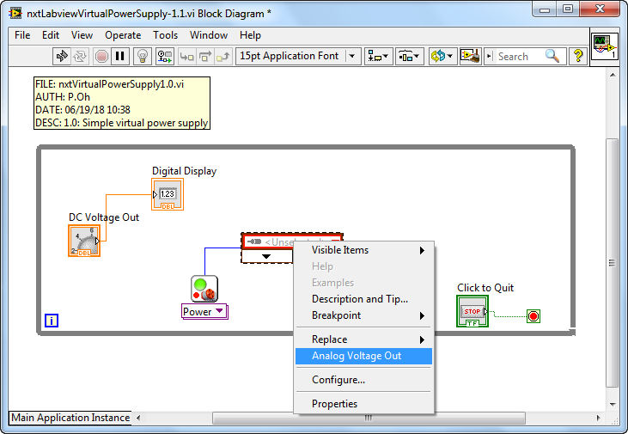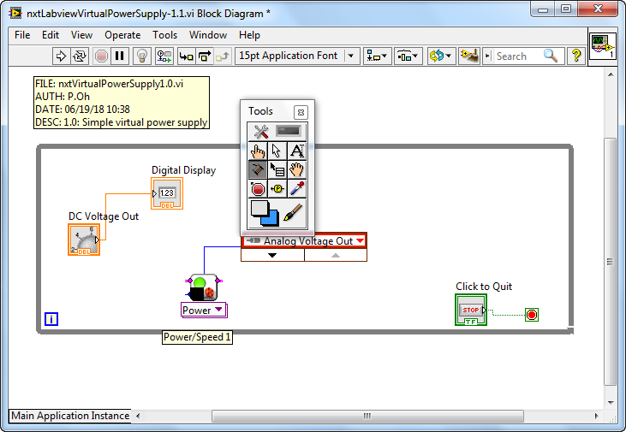

Lastly, complete wiring of the components as seen in **Figure 1L**.

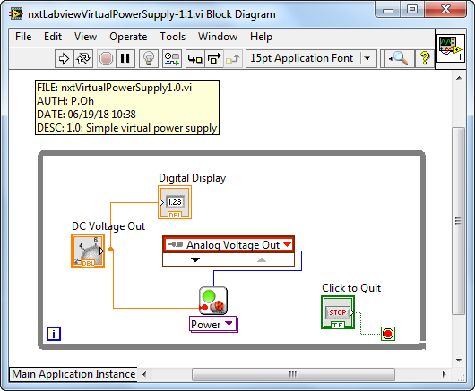

**Figure 1L:** Final wiring for block diagram

**Step 4:** Breadboard connections and testing

The NXT Brick’s **Ports A, B, and C** can be programmed as an adjustable power source. The cable has the pin-out shown in **Figure 1M**.

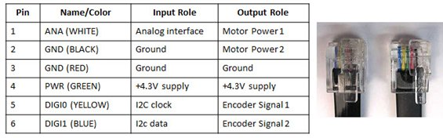

**Figure 1M:** A standard NXT cable consists of 6 colored wires. When this cable is plugged into the brick’s output port, and then each wire has the function given in the right-most column.

Connect your NXT Brick and PC with a USB cable and power on the Brick. Next, insert the NXT adapter into the breadboard. Connect the Brick’s Port B and NXT adapter with an NXT cable as seen in **Figure 1N (left).** This NXT adapter provides easy access to the 6 colored wires of the NXT cable and Port. **Figure 1N (right)** shows a white and black jumper wire connected to Pins 1 and 2 respectively. The wires are then connected to a voltmeter. The table in Figure 1M shows that Pins 1 and 2 serve as Motor Power 1 and Motor Power 2 when connected to an output port (like Port B).

**Figure 1N:** Breadboard connections (left) and NXT adapter close up (right)

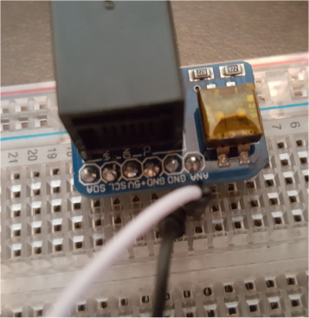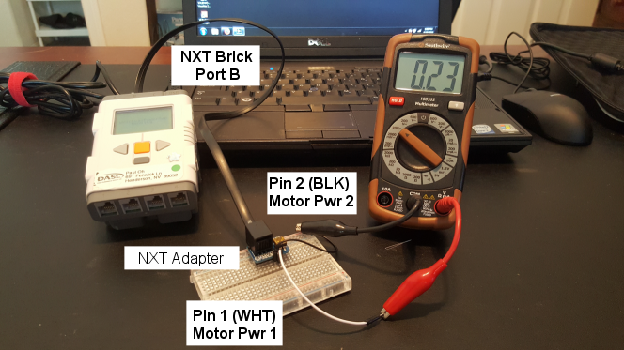

Executing the program, with the knob about half-way (e.g. 2.5), one sees that the voltmeter (in **Figure 1M**) only generates 0.23 Volts. With the knob fully clockwise (e.g. 5), the voltmeter displays only 0.44 Volts. These values will depend on the value (i.e. freshness) of your NXT Brick’s batteries.

**Figure 1M:** Running the program and setting the knob about halfway (left) results in only 0.23 Volts on the voltmeter (right)

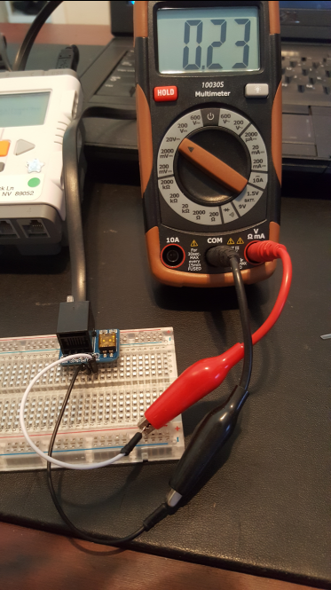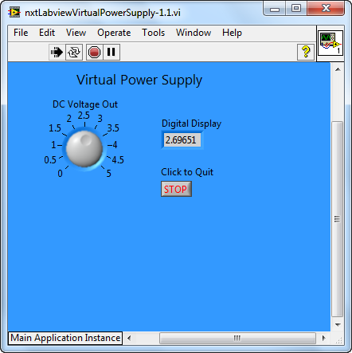

This is to be expected. This is because the Power control element in the block diagram expects an input in terms of percentage power. In other words, an input of 100 means 100% power. 100% power depends on voltage-level of the NXT’s batteries. Thus, one needs scaling.

**Step 5:** Add scaling factor

**Figure 1N** shows a scaling factor added to the block diagram and consequential wiring. This scale factor uses the fact that a knob value of 2.7 resulted in only 0.23 Volts. Thus, this ratio was used to multiple the knob value which then inputs into the Power component.

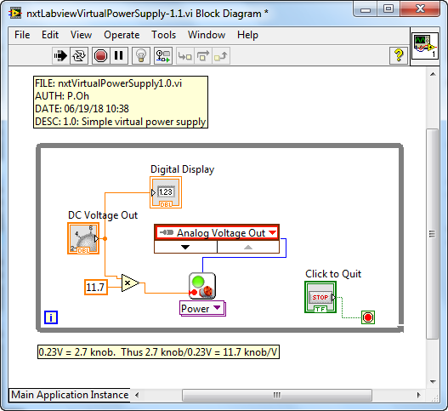

**Figure 1N:** A multiply component was inserted into the block diagram to scale power

Clicking run shows the expected and desired results as shown in **Figure 1O**.

As

**Figure 1O:** Voltmeter (right) displaying desired knob value (left)

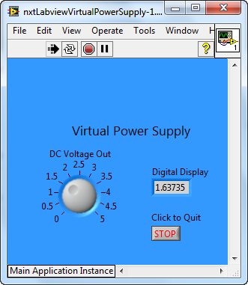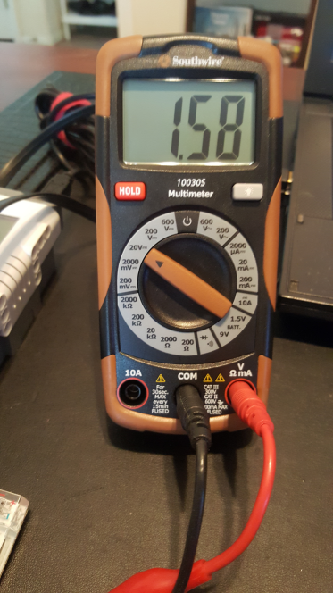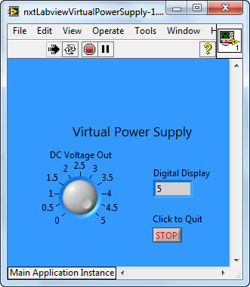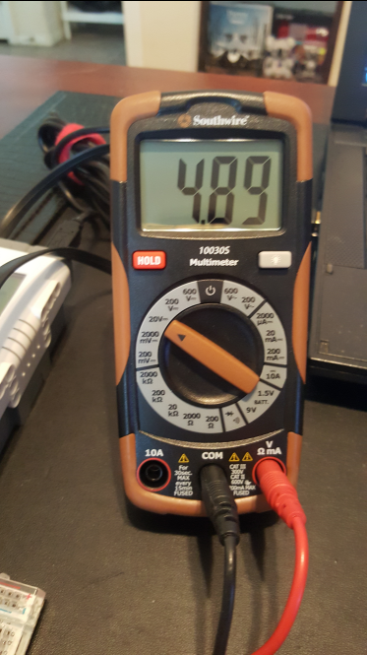

Congratulations! You created your first virtual instrumentation, a 5V power supply

**Exercise 1:** In LabVIEW create programs for the following:

* 1. A virtual power supply ranging from –5 to +5 Volts. Connect NXT motor to see effect.
  2. Display the output voltage on a waveform chart (select Graph Inds – Chart)